Signals Quick Guide
This guide is intended to give an installer instructions to get the Signals Server running and connected to the network.
Things you will need:
- Signals Server
- HDMI Headless Adapter (included)
- Network Connection
- Network Address
  - Signals requires a network connection that allows outbound connectivity to the public internet
  - See the facility network administrator
- Laptop
  - The Signals Server comes configured with a default static IP Address (172.30.30.61)
  - You will need to put a laptop (or other PC) on the same network to access the built-in web server to configure the IP Address

Setup
The following steps should be followed to get the Signals Server up and accessible on the network
- Plug in the HDMI Headless Adapter prior to powering on the server
- Connect a network cable
- Connect the power cable
- If the PC does not automatically start, be sure that the power switch on the back is in the ‘on’ position.
- Add your laptop onto the same network with the Signals server.

Changing The IP Address
The IP Address can be changed via a web-based configuration tool. The following steps show how to do this.
First, browse to the default address of the Signals server:
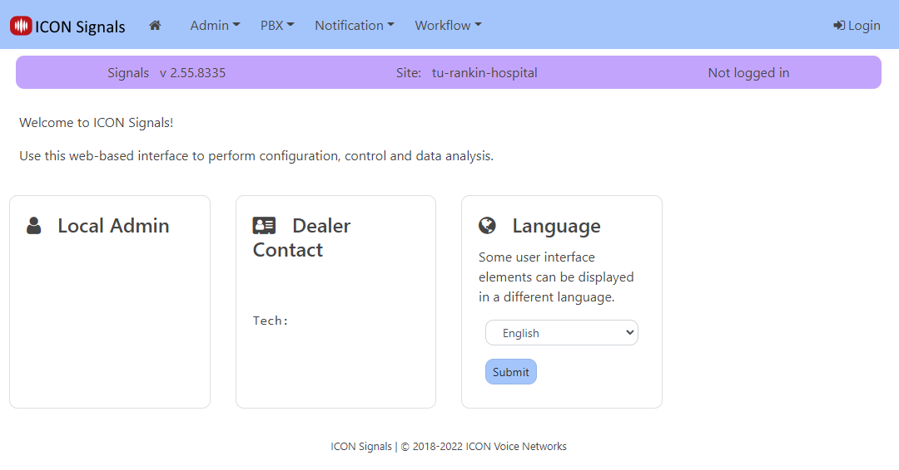
Figure 1: Signals Web Page

Next, click “Login” in the upper right corner of the page. You will be prompted for credentials:
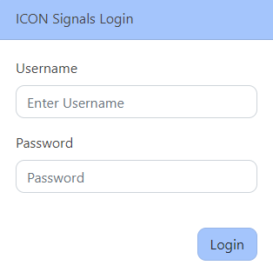
Figure 2: Logging In
Enter the following credentials:
Username: admin
Password: admin12345
You will be logged in as shown:
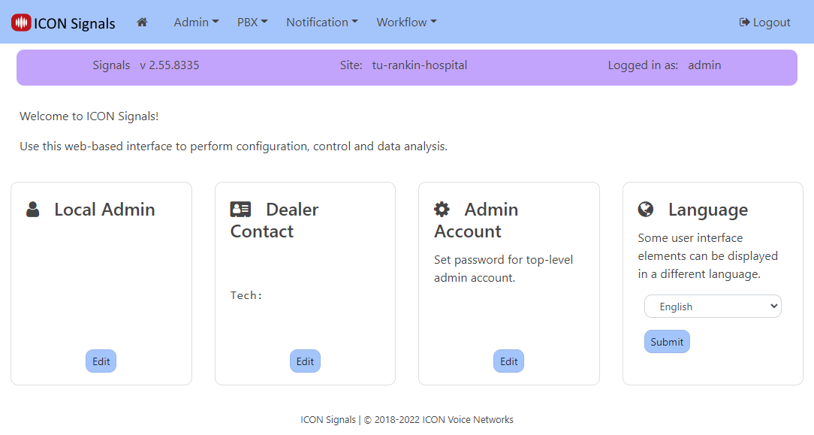
Figure 3: Logged In

Along the top menu, click “Admin” and then select “Configuration”:
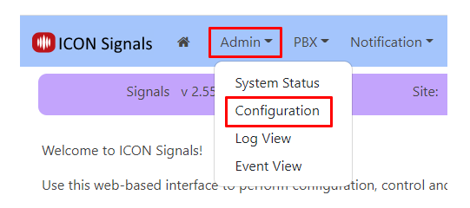
Figure 4: Navigate To Configuration

This takes you to the Configuration page:
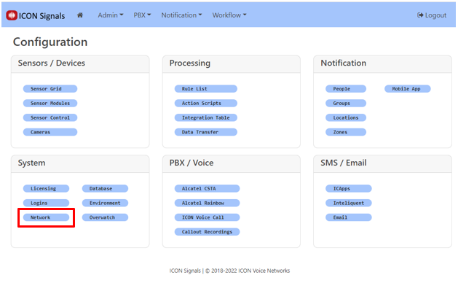
Figure 5: Configuration

Now, select “Network”:
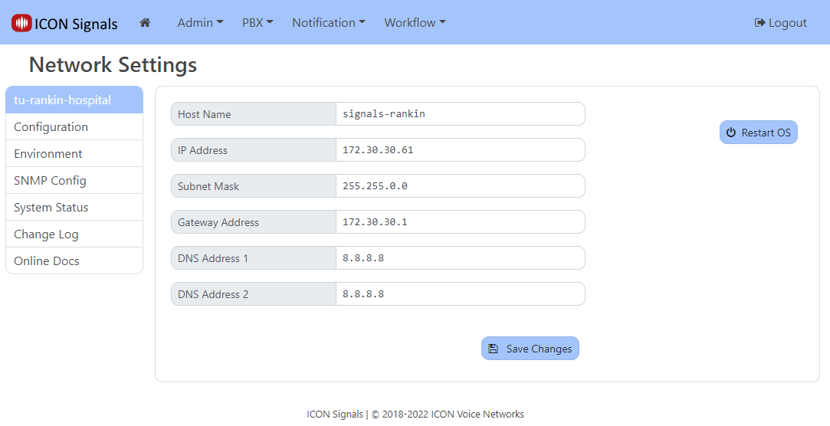
Figure 6: Network Configuration
Fill in the network settings with the information received from the facility network administrator and click “Save Changes”. Next, click “Restart OS” to make the changes take effect. You will have to confirm the reset. Once you do, the server will reboot in roughly one minute. After that it should be on the network and ready to use.

